U.S. Department of Veterans Affairs Office of Mental Health and Suicide Prevention

Social Media Content Calendar – Dial 988 then Press 1

 | Facebook Copy | Twitter Copy | Instagram Copy | Media Asset
For Veterans
1 | The Veterans Crisis Line has a new number—Dial 988 then Press 1. Save it in your phone today.  Learn more: VeteransCrisisLine.net | The #VeteransCrisisLine has a new number—Dial 988 then Press 1. Save it in your phone today.  Learn more: VeteransCrisisLine.net | The #VeteransCrisisLine has a new number—Dial 988 then Press 1. Save it in your phone today.  Learn more: VeteransCrisisLine.net  #SuicidePrevention  #SuicideAwareness | Facebook/Twitter  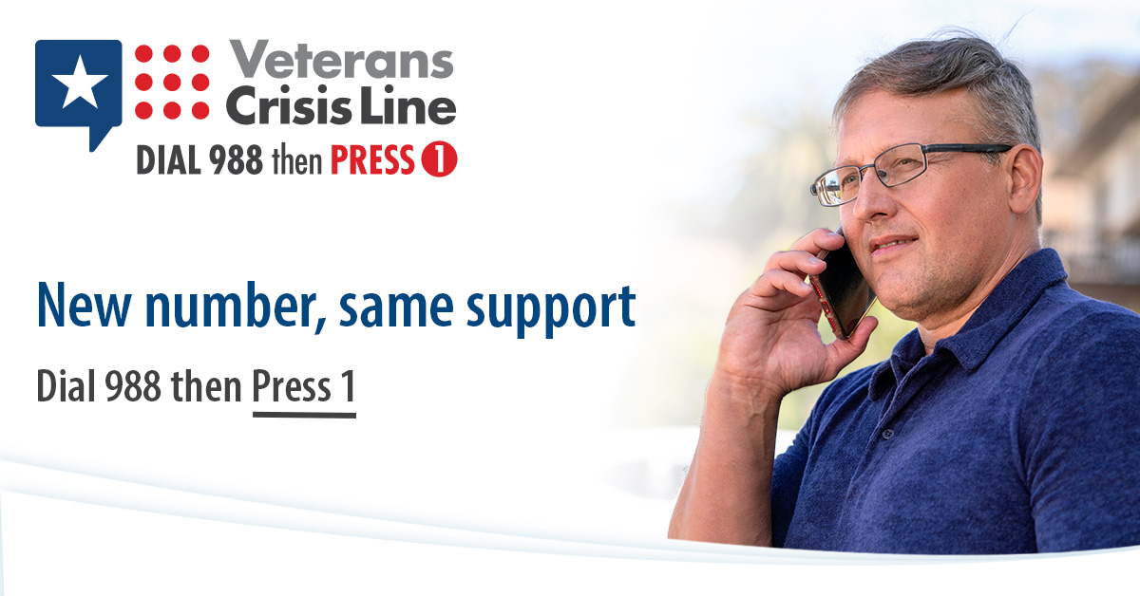  Instagram
2 | If you or a Veteran you know is in crisis, call the Veterans Crisis Line’s new number now: Dial 988 then Press 1.  VeteransCrisisLine.net | If you or a #Veteran you know is in crisis, call the #VeteransCrisisLine’s new number now: Dial 988 then Press 1.  VeteransCrisisLine.net | If you or a #Veteran you know is in crisis, call the #VeteransCrisisLine’s new number now: Dial 988 then Press 1.  VeteransCrisisLine.net  #SuicidePrevention  #SuicideAwareness | Facebook/Twitter  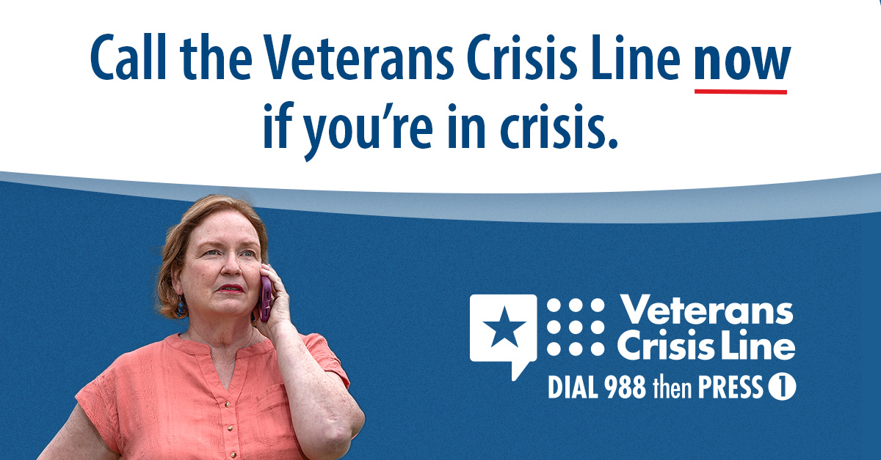  Instagram
3 | Don’t wait. Save the new Veterans Crisis Line number in your phone—Dial 988 then Press 1.  Learn more at: VeteransCrisisLine.net | Don’t wait. Save the new #VeteransCrisisLine number in your phone—Dial 988 then Press 1.  Learn more at: VeteransCrisisLine.net | n/a | Facebook/Twitter  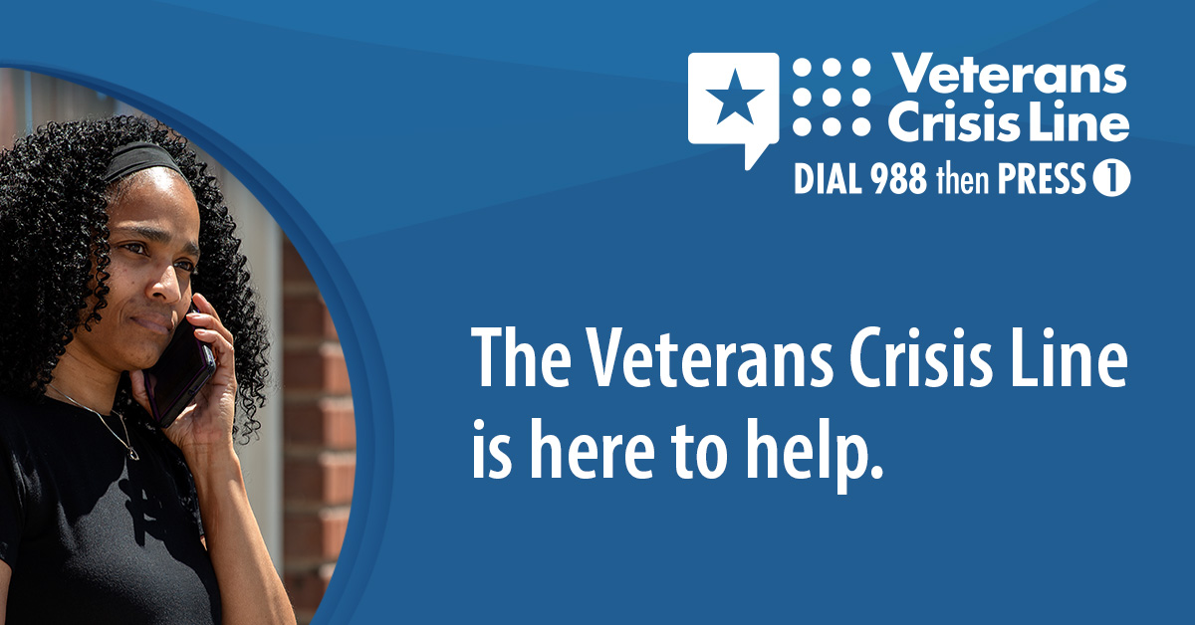  Instagram Story  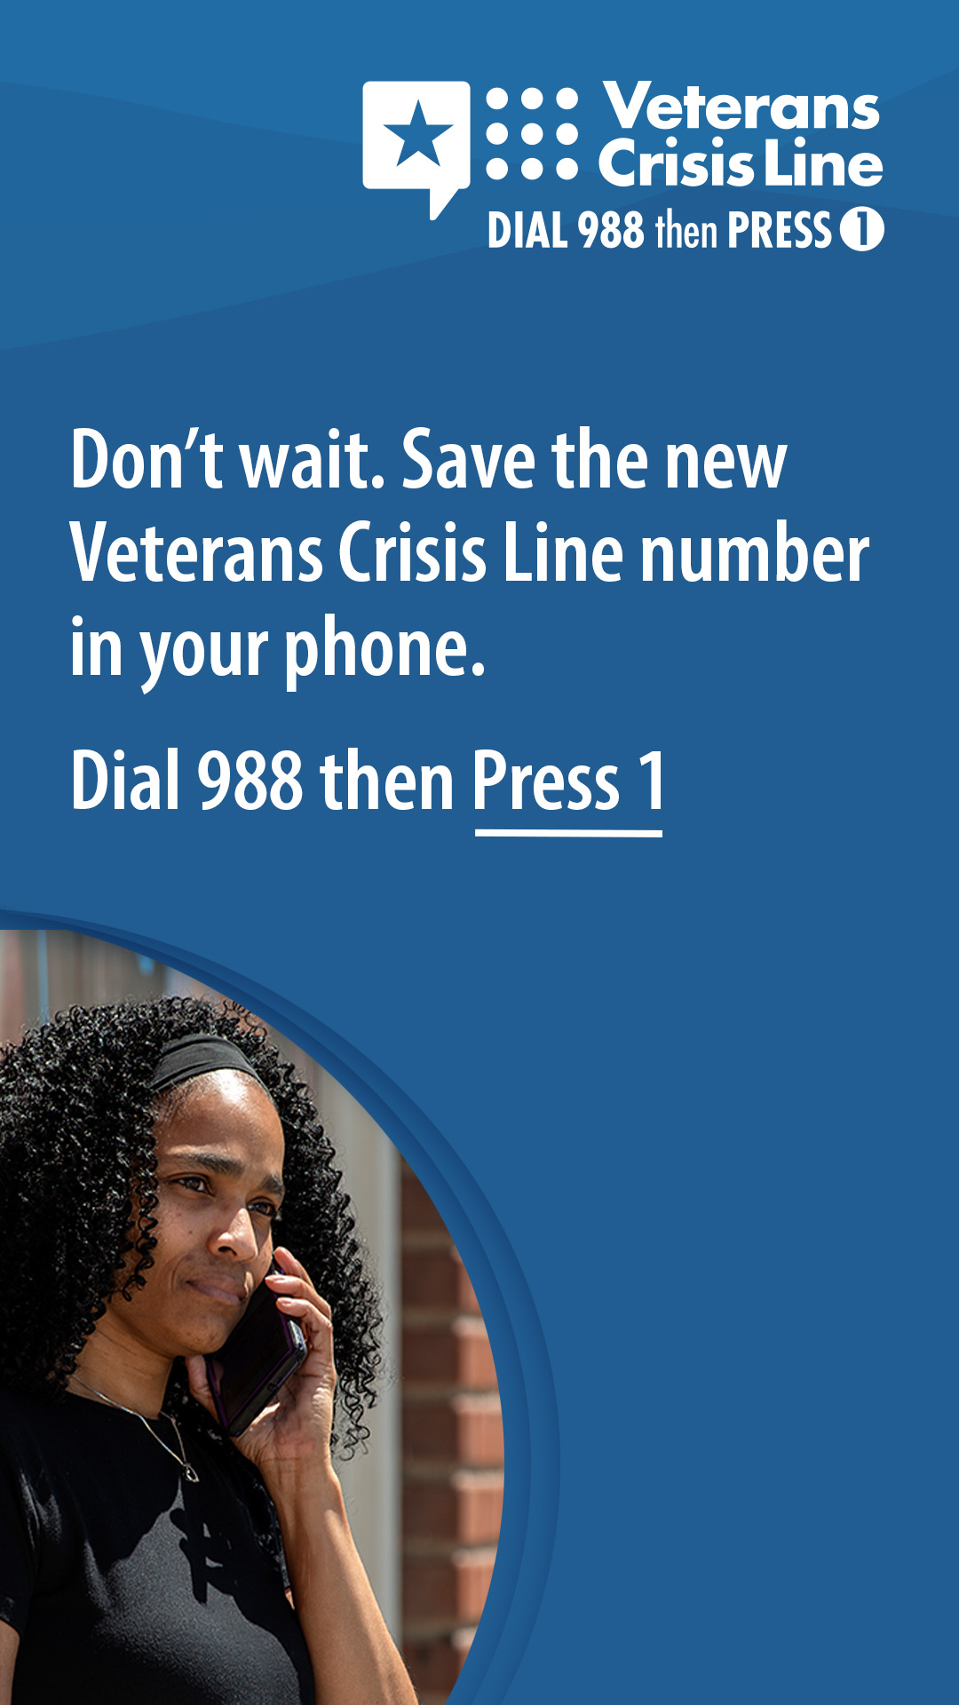
4 | The Veterans Crisis Line has a new, easier-to-remember number: Dial 988 then Press 1.  Learn more: VeteransCrisisLine.net | The #VeteransCrisisLine has a new, easier-to-remember number: Dial 988 then Press 1.  Learn more: VeteransCrisisLine.net | The #VeteransCrisisLine has a new, easier-to-remember number: Dial 988 then Press 1.  Learn more: VeteransCrisisLine.net  #SuicidePrevention  #SuicideAwareness | Facebook/Twitter  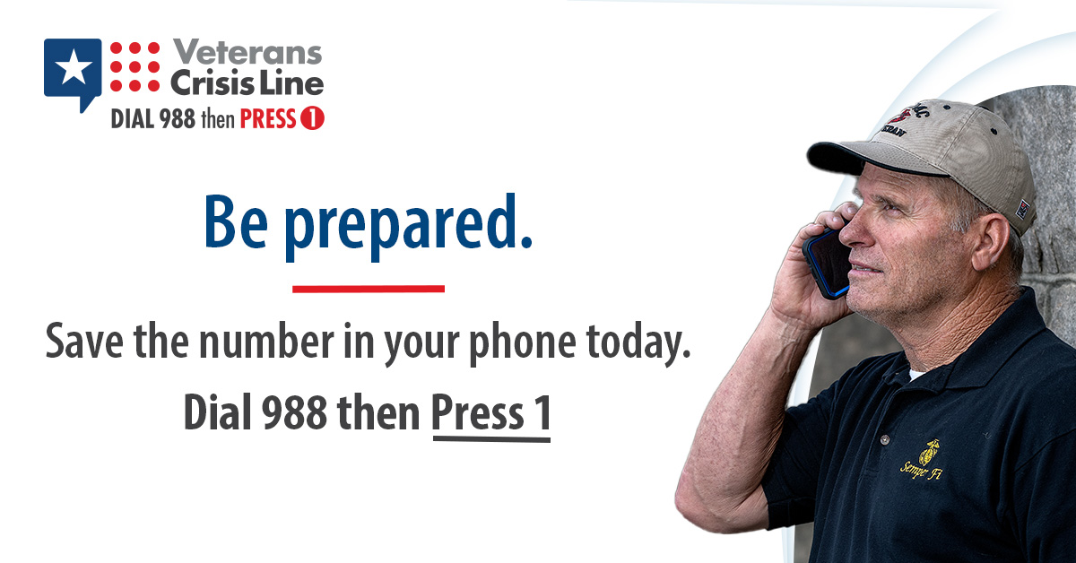  Instagram  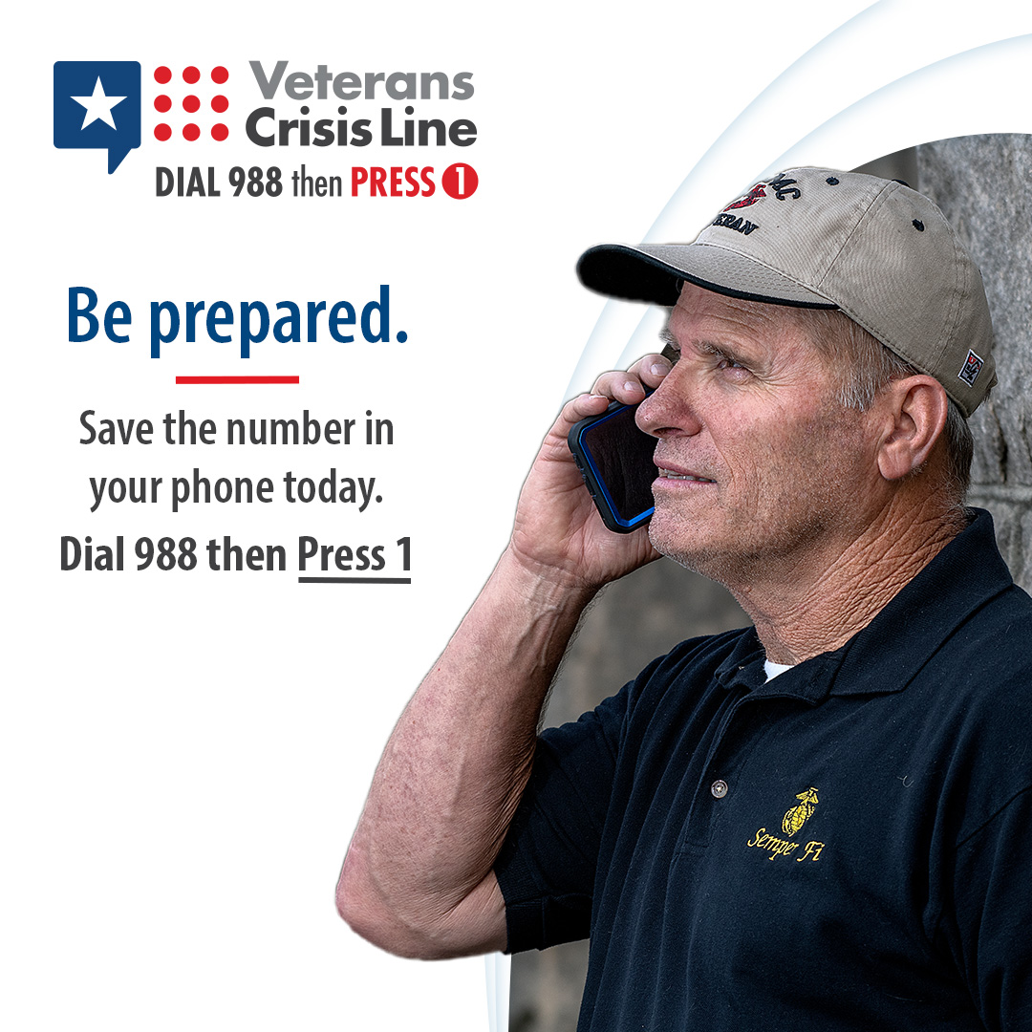
5 | New number, same support. Save the new Veterans Crisis Line number in your phone—Dial 988 then Press 1.  Learn more: VeteransCrisisLine.net | New number, same support. Save the new #VeteransCrisisLine number in your phone—Dial 988 then Press 1.  Learn more: VeteransCrisisLine.net | New number, same support. Save the new #VeteransCrisisLine number in your phone—Dial 988 then Press 1.  Learn more: VeteransCrisisLine.net  #SuicidePrevention  #SuicideAwareness | Facebook/Twitter  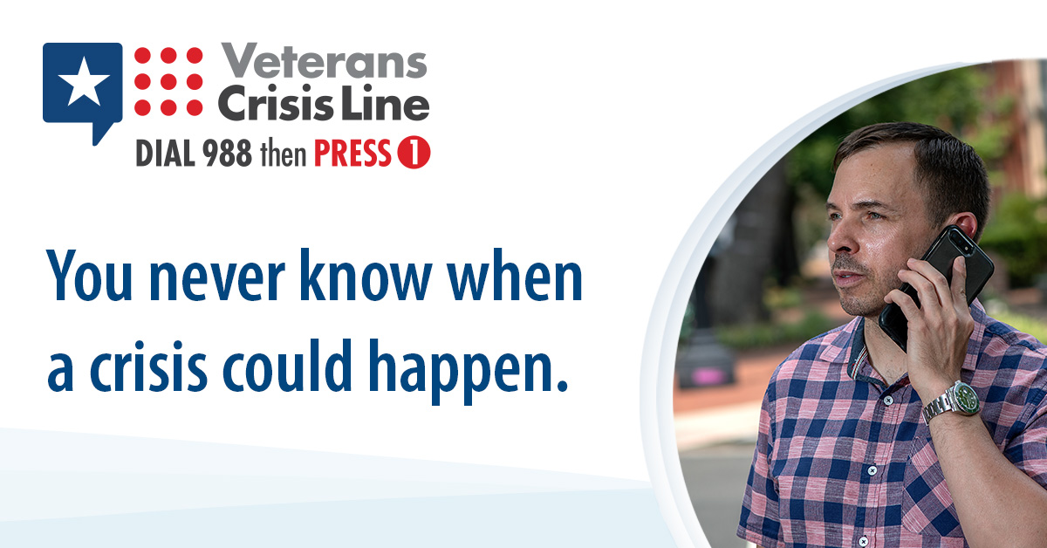  Instagram
6 | You don’t have to go through a crisis alone. Dial 988 then Press 1 to reach the Veterans Crisis Line day or night.  Visit VeteransCrisisLine.net. | You don’t have to go through a crisis alone. Dial 988 then Press 1 to reach the #VeteransCrisisLine day or night.  Visit VeteransCrisisLine.net. | n/a | Facebook/Twitter  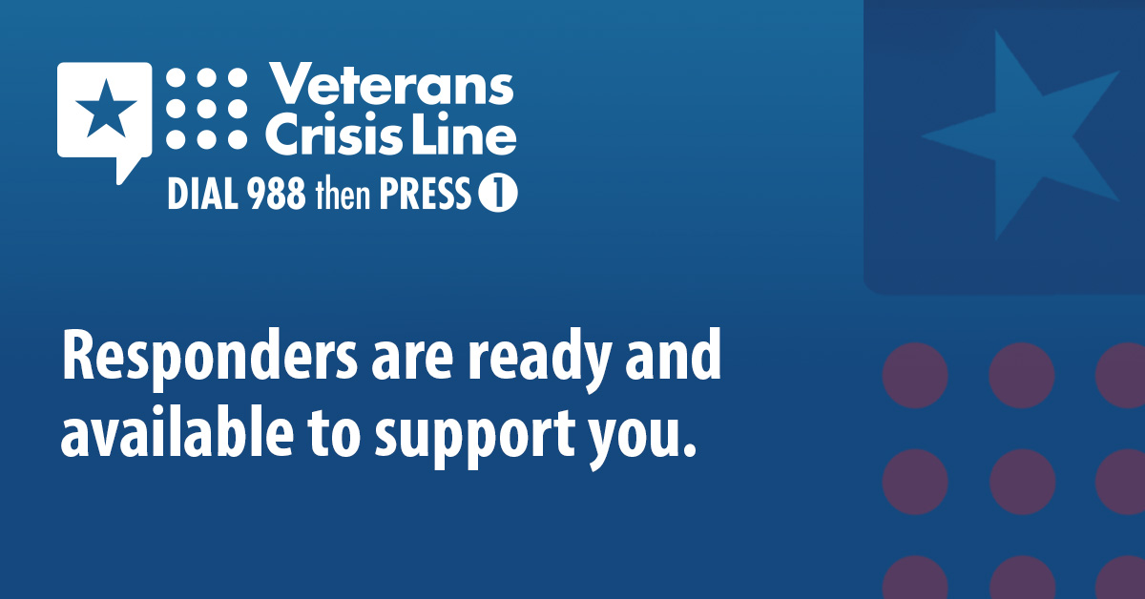  Instagram Story  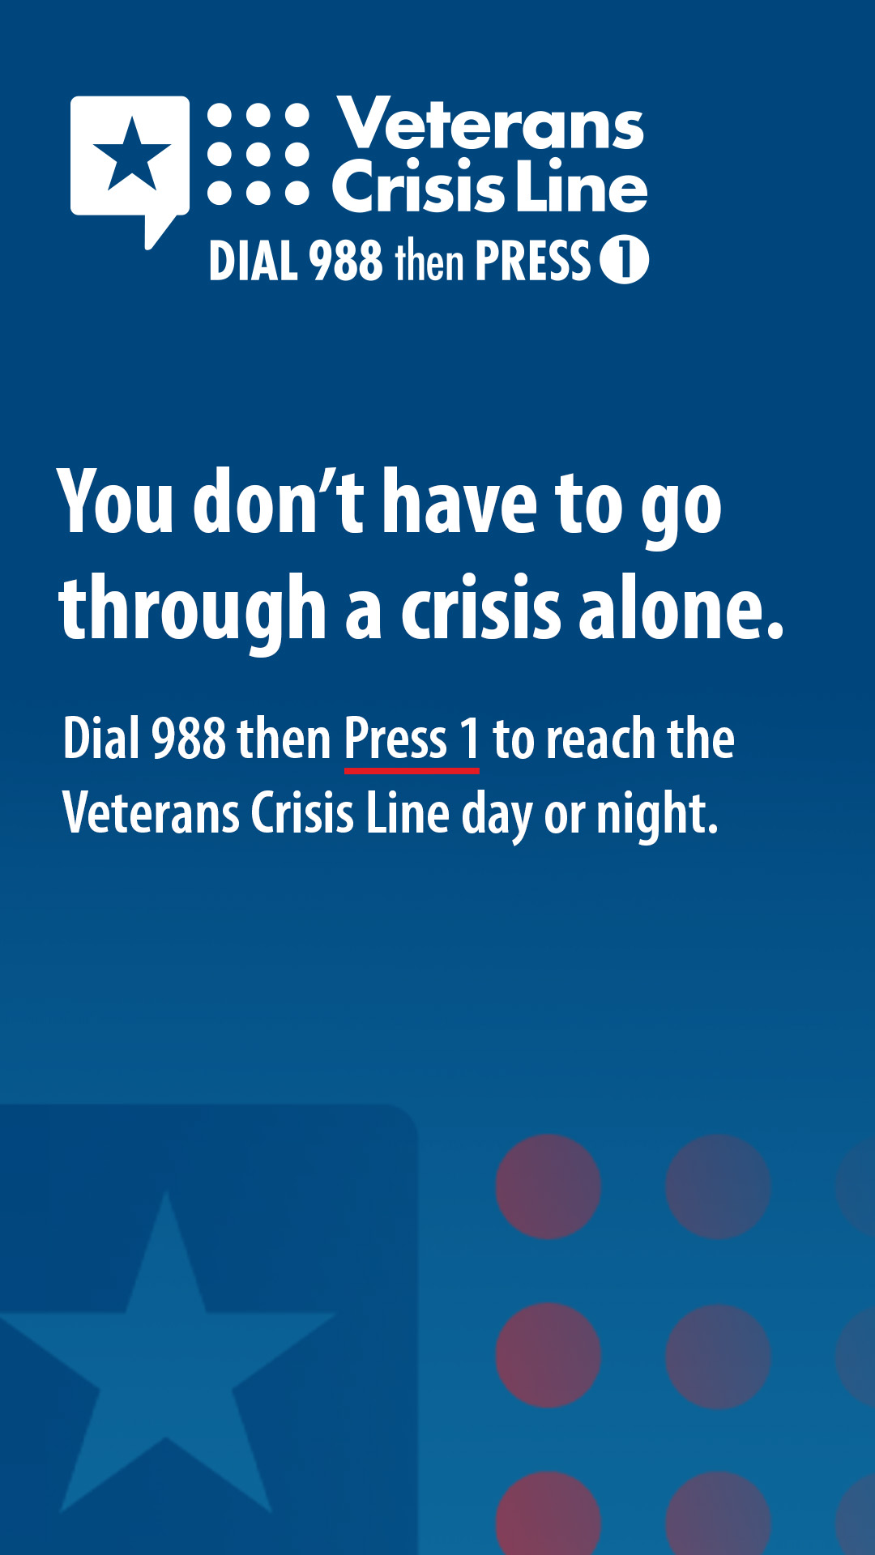
For Supporters
7 | The Veterans Crisis Line has a new, easier-to-remember number for Veterans and their supporters. Share this post to spread the word.  VeteransCrisisLine.net | The #VeteransCrisisLine has a new, easier-to-remember number for #Veterans and their supporters. Retweet this to spread the word.  VeteransCrisisLine.net | The #VeteransCrisisLine has a new, easier-to-remember number for #Veterans and their supporters. Share this to your Story to spread the word.  VeteransCrisisLine.net  #SuicidePrevention  #SuicideAwareness | Facebook/Twitter  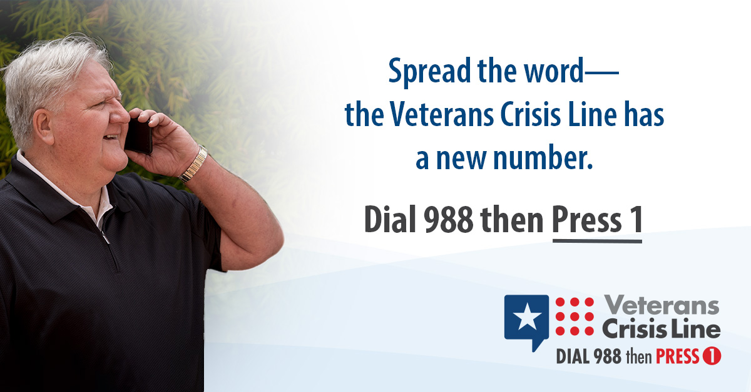  Instagram  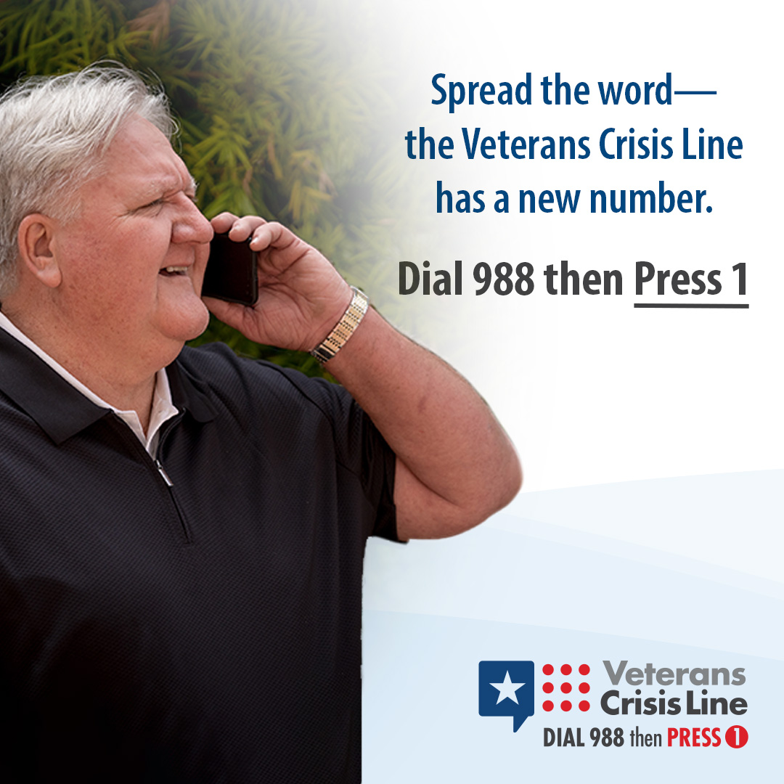
8 | Save the new Veterans Crisis Line number to your phone. Dial 988 then Press 1. You never know when you or someone you care about may need it.  Find out more at: VeteransCrisisLine.net | Save the new #VeteransCrisisLine number to your phone: Dial 988 then Press 1. You never know when you or someone you care about may need it.  Find out more at: VeteransCrisisLine.net | n/a | Facebook/Twitter  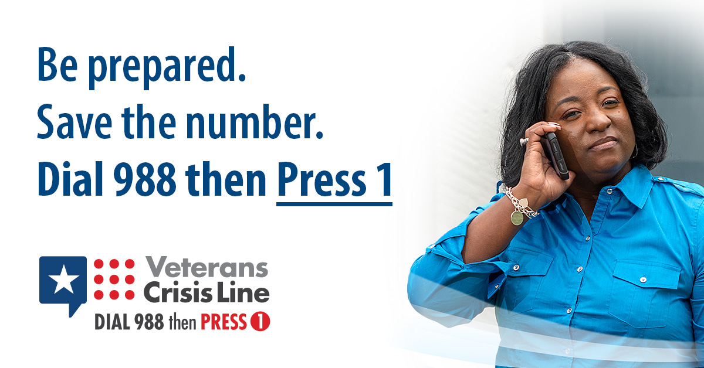  Instagram Story  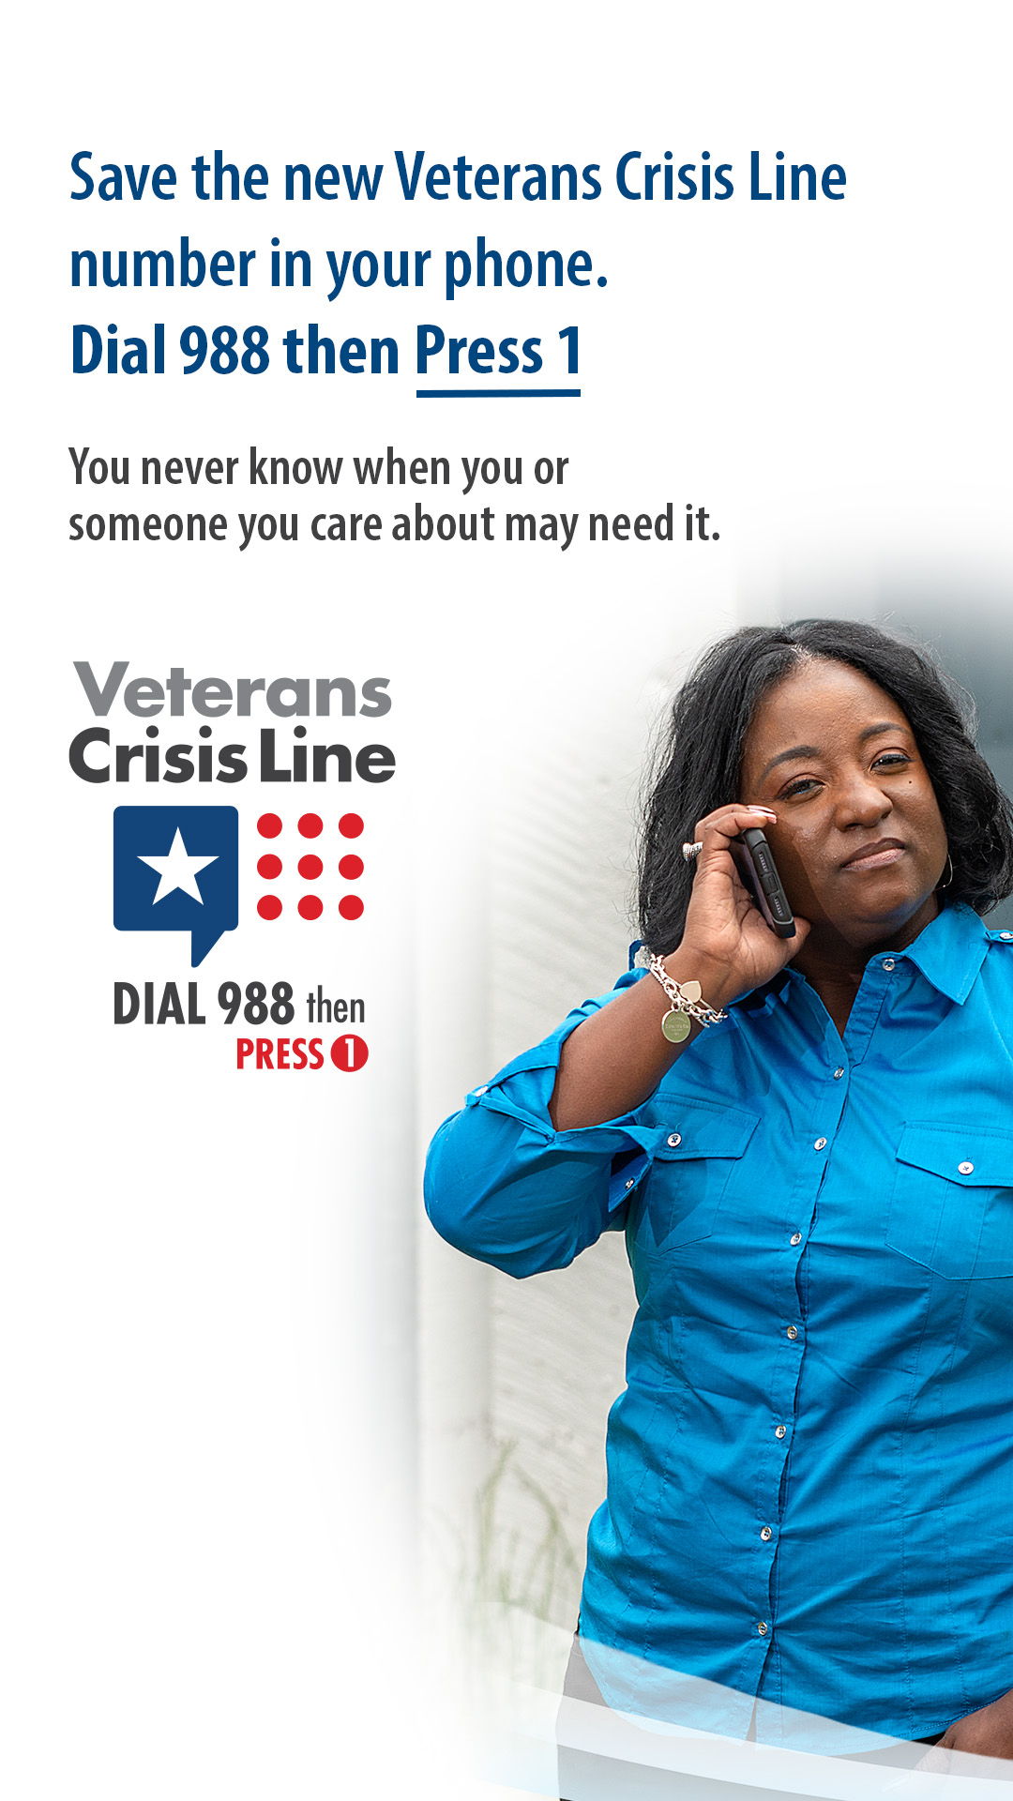
9 | No Veteran should go through a crisis alone. Share the Veterans Crisis Line number with Veterans you know so they have support if they need it.  VeteransCrisisLine.net | No #Veteran should go through a crisis alone. Share the #VeteransCrisisLine number with Veterans you know so they have support if they need it.  VeteransCrisisLine.net | No #Veteran should go through a crisis alone. Share the #VeteransCrisisLine number with Veterans you know so they have support if they need it.  VeteransCrisisLine.net  #SuicidePrevention  #SuicideAwareness | Facebook/Twitter  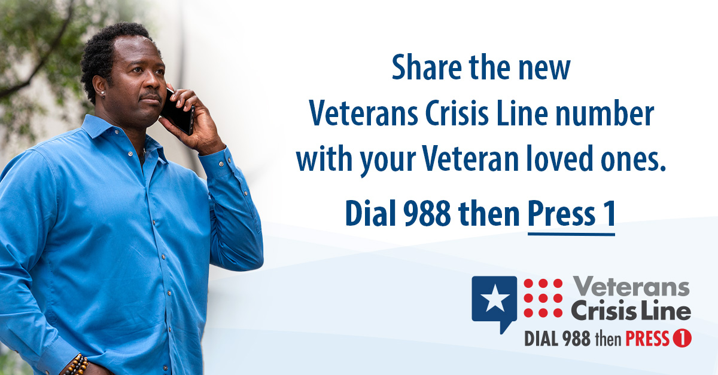  Instagram  