U.S. Department of Veterans Affairs Office of Mental Health & Suicide Prevention

Winter Veterans Crisis Line Social Media Posts

Facebook Copy | Twitter Copy | Instagram Copy | Media Asset
The Veterans Crisis Line is prepared to help with any crisis a Veteran may be facing. Call 1-800-273-8255 and Press 1 to connect with a qualified professional today.  VeteransCrisisLine.net | The #VeteransCrisisLine is prepared to help with any crisis a #Veteran may be facing. Call 1-800-273-8255 and Press 1 to connect with a qualified professional today.  VeteransCrisisLine.net | The #VeteransCrisisLine is prepared to help with any crisis a #Veteran may be facing. Call 1-800-273-8255 and Press 1 to connect with a qualified professional today.  VeteransCrisisLine.net  #SuicidePrevention #SuicideAwareness | Facebook/Twitter  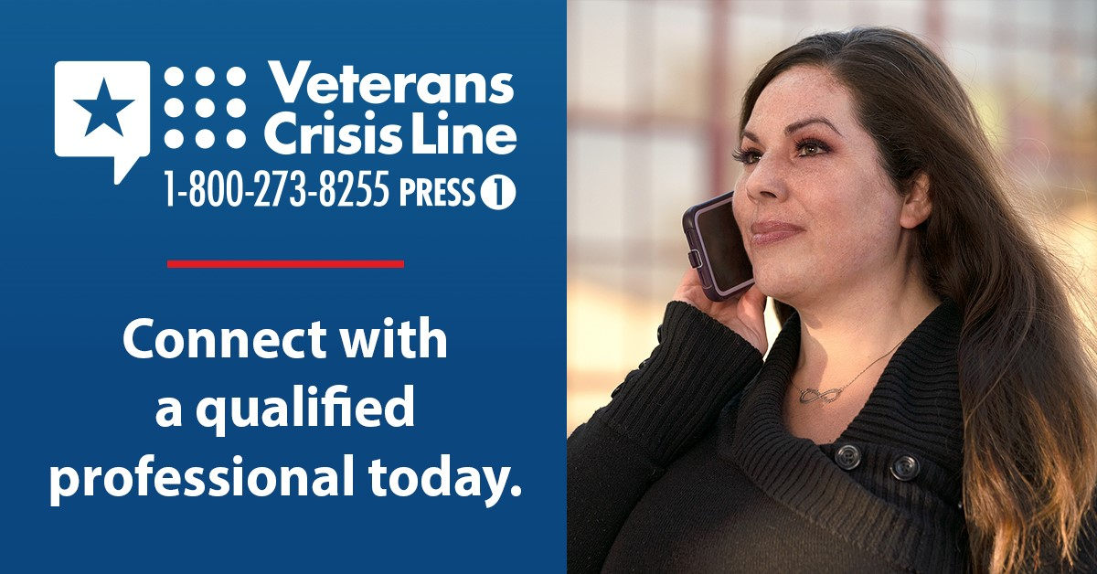  Instagram:
The Veterans Crisis Line helps prevent suicide by offering free, 24/7 confidential support to all Veterans, as well as their friends and family.  VeteransCrisisLine.net | The #VeteransCrisisLine helps prevent suicide by offering free, 24/7 confidential support to all Veterans, as well as their friends and family.  VeteransCrisisLine.net | The #VeteransCrisisLine helps prevent suicide by offering free, 24/7 confidential support to all Veterans, as well as their friends and family.  VeteransCrisisLine.net  #SuicidePrevention #SuicideAwareness | Facebook/Twitter  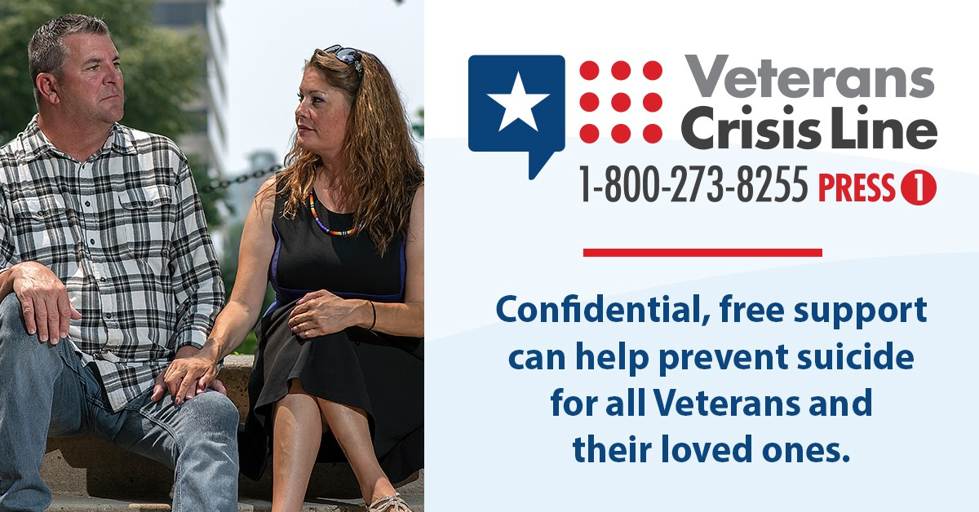  Instagram  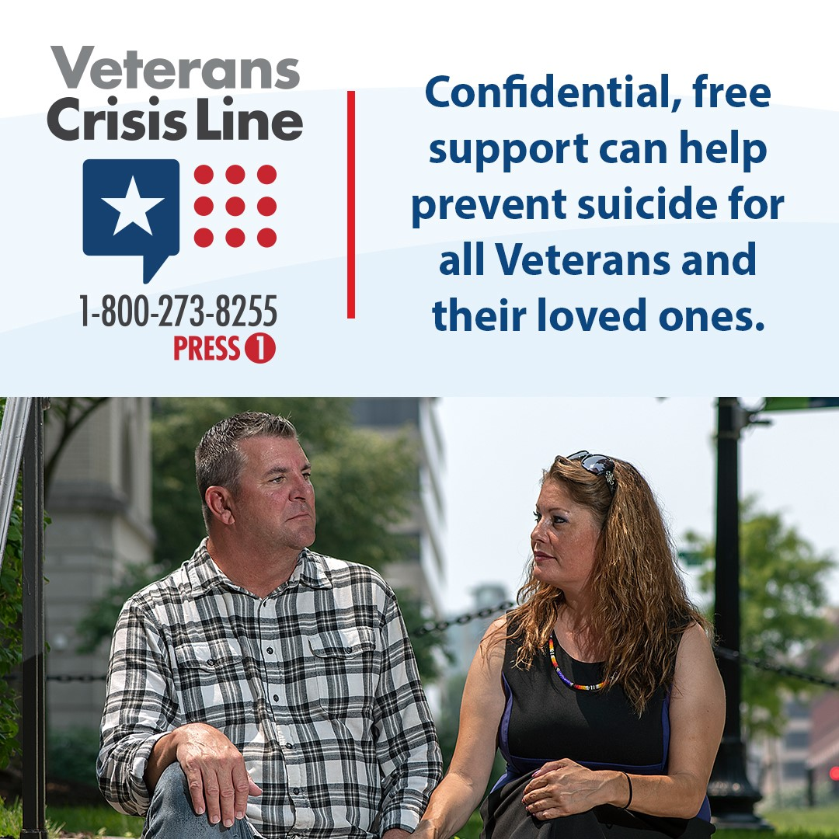
Is the Veterans Crisis Line number saved in your phone? Save it today so you’re prepared in case of a crisis.  VeteransCrisisLine.net | Is the #VeteransCrisisLine number saved in your phone? Save it today so you’re prepared in case of a crisis.  VeteransCrisisLine.net | Is the #VeteransCrisisLine number saved in your phone? Save it today so you’re prepared in case of a crisis.  VeteransCrisisLine.net  #SuicidePrevention #SuicideAwareness | Facebook/Twitter  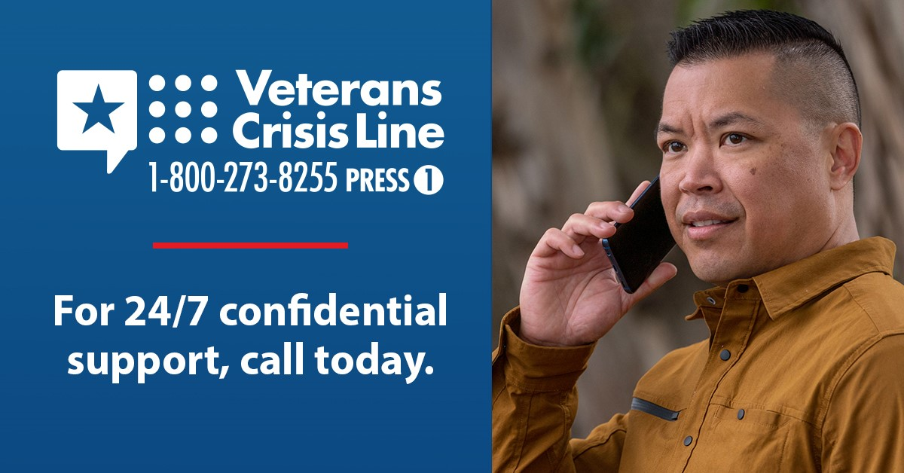  Instagram  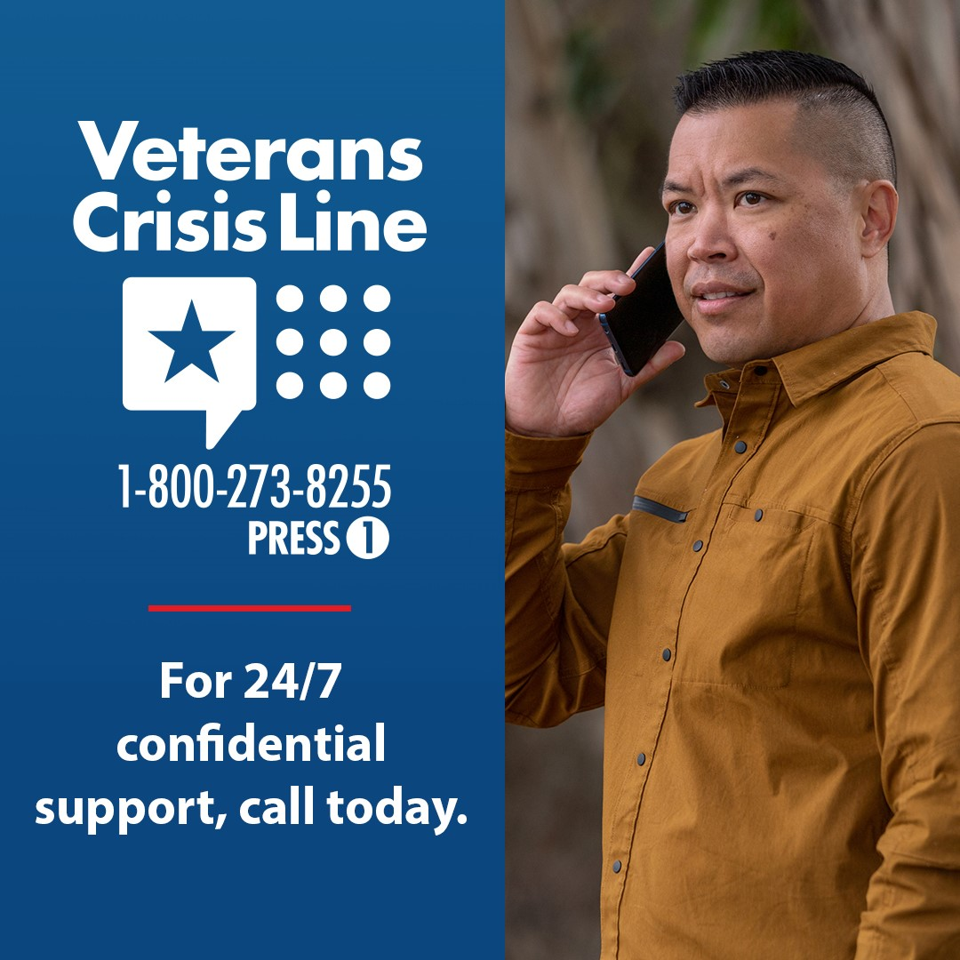
Be prepared in case of a crisis. Save the Veterans Crisis Line to your phone and make sure your Veteran loved ones do, too —1-800-273-8255 and Press 1.  VeteransCrisisLine.net | Be prepared in case of a crisis. Save the #VeteransCrisisLine to your phone and make sure your Veteran loved ones do, too —1-800-273-8255 and Press 1.  VeteransCrisisLine.net | Be prepared in case of a crisis. Save the #VeteransCrisisLine to your phone and make sure your Veteran loved ones do, too —1-800-273-8255 and Press 1.  VeteransCrisisLine.net  #SuicidePrevention #SuicideAwareness | Facebook/Twitter  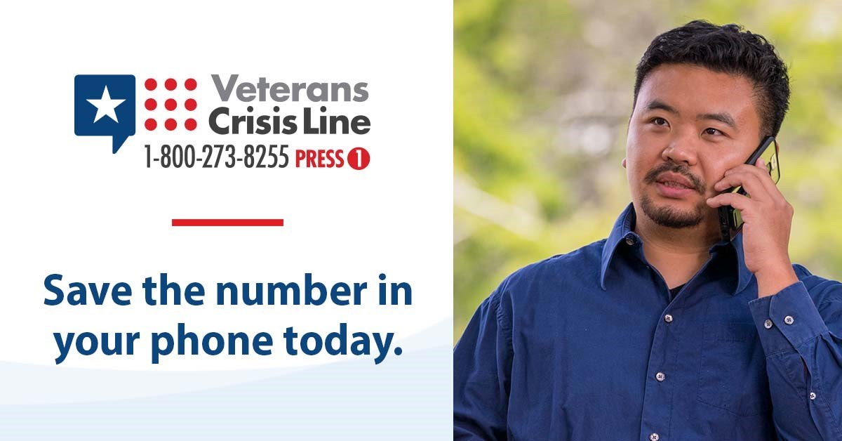  Instagram
If you’re experiencing thoughts of suicide, call now—1-800-273-8255 and Press 1. The Veterans Crisis Line has caring, qualified people ready to listen. VeteransCrisisLine.net | If you’re experiencing thoughts of suicide, call now—1-800-273-8255 and Press 1. The #VeteransCrisisLine has caring, qualified people ready to listen. VeteransCrisisLine.net | If you’re experiencing thoughts of suicide, call now—1-800-273-8255 and Press 1. The #VeteransCrisisLine has caring, qualified people ready to listen. VeteransCrisisLine.net  #SuicidePrevention #SuicideAwareness | Facebook/Twitter  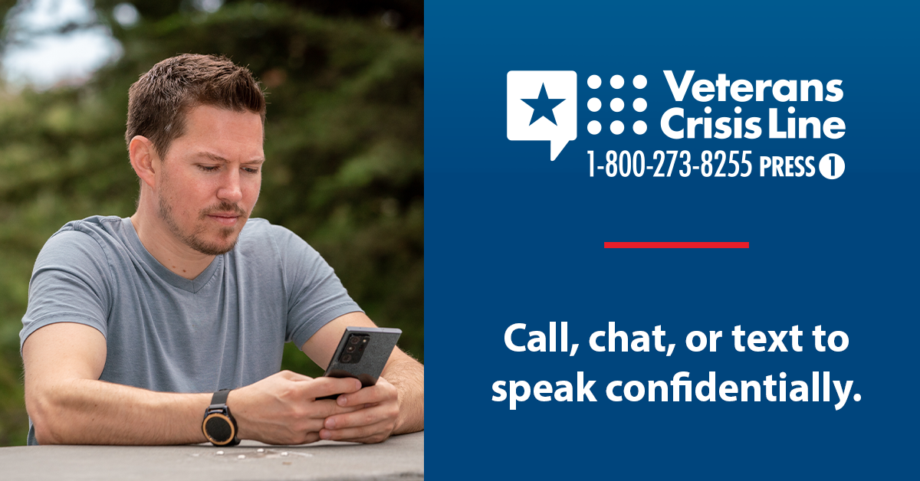  Instagram  